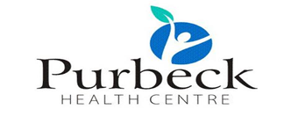

Notice to Patients – Gifts and Donations

- 💙 We are very grateful for the kindness and generosity shown by our patients.

- ⚠️ However, NHS guidance and CQC requirements mean that:
  - Staff cannot accept cash, vouchers, or high-value gifts
  - Small tokens such as chocolates, biscuits, or flowers may be accepted and shared with the team
  - All gifts must be recorded in our Gifts & Hospitality Register
🙏 Thank you for your understanding and support.

